What is output of the following program and Explain your answer? (4 points)
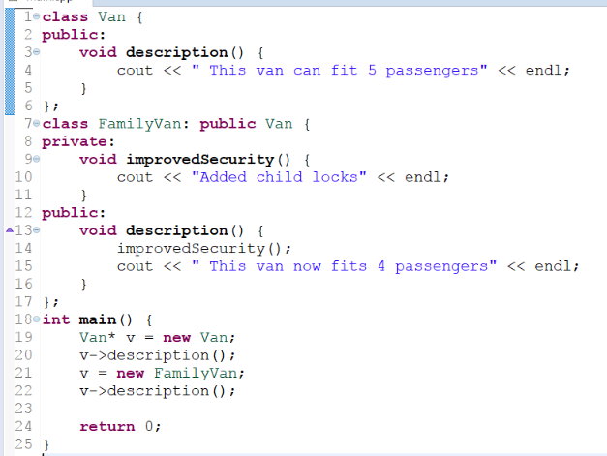

This van can fit 5 passengers
Added child locks
This van now fits 4 passengers

The first description calls on a regular van so it uses the van’s description method but the second one goes to the FamilyVan’s method, which first calls improvedSecurity, then it calls the new description

What happens when you execute the following C++ program? Explain your answer in detail. (4 points)
#include <iostream>
class Animal{
public:
virtual void canWalk() = 0;
virtual void canEat() = 0;
};
class Tiger: public Animal{
public:
void canWalk(){
std::cout<<"Can Walk on four legs"<<std::endl;
}
};
int main(){
Animal* a = new Tiger;
a->canWalk();
delete a;
}

What happens when you executed the following C++ program. Explain your answer in detail. If it runs, what is the output. If not, where and what are the errors (use the line numbers) and how to fix them. (4 points).
- #include <iostream>
- using namespace std;
- const double PI = 3.141;

- void calArea(const double& area, const double radius){
- area = PI * radius * radius;
- }

- int main(){
- double area = 0.0;
- double radius = 10.0;
- double& ref2Radius;

- calArea(area, radius);

- cout<<”Area is – “<<area<<endl;

- }

